Step 1:

Follow this link: <https://www.virtusonline.org/virtus/reg_list.cfm?theme=0>

And choose your Diocese.

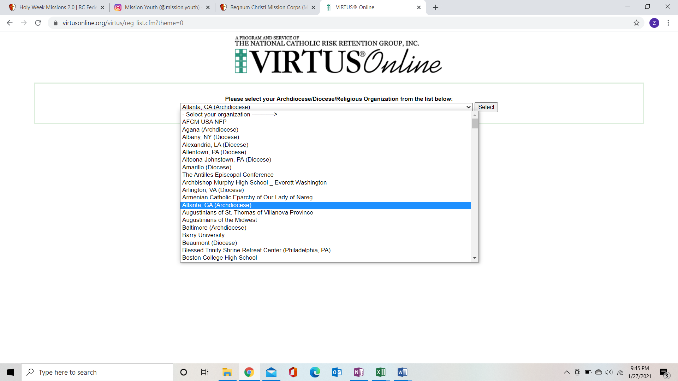

Step 2:

* Once you select your diocese, it will bring you to a list of the classes offered at parishes near you.
* Find your parish or one that is close and select that one.
* It will have a phone number or email of the person to contact for that specific class.

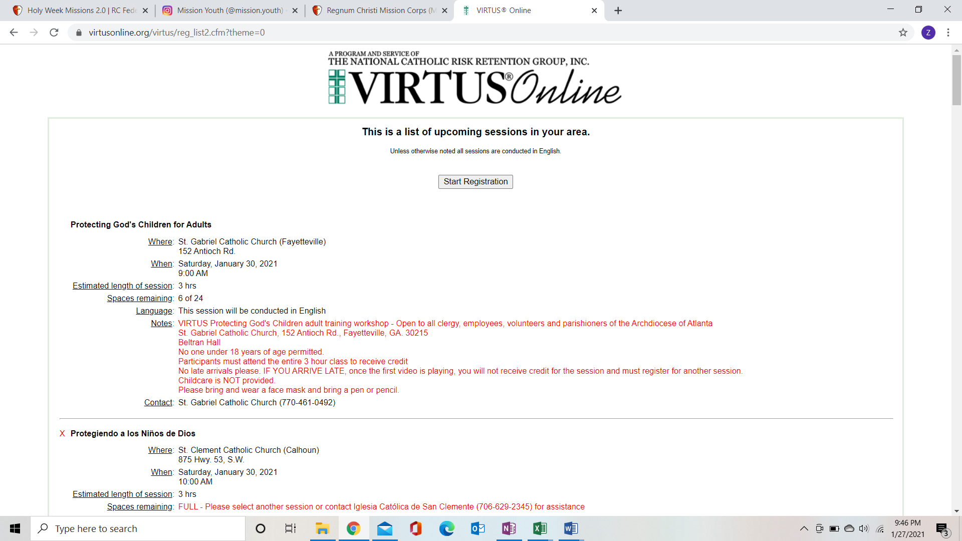

Contact Zoe if you have trouble finding a class in your area.

NOTE\* this must be completed before you go to the summer program unless you are not yet 18 by that time.

[Zkayser@rcfed.org](mailto:Zkayser@rcfed.org)